**SqL Server Advanced 4**

**Task1:**

Create table Department

(

ID int primary key,

DepartmentName nvarchar(50),

Location nvarchar(50),

DepartmentHead nvarchar(50)

)

Go

Insert into Department values (1, 'IT', 'London', 'Rick')

Insert into Department values (2, 'Payroll', 'Delhi', 'Ron')

Insert into Department values (3, 'HR', 'New York', 'Christie')

Insert into Department values (4, 'Other Department', 'Sydney', 'Cindrella')

Go

Create table Employee

(

ID int primary key,

Name nvarchar(50),

Gender nvarchar(50),

Salary int,

DepartmentId int foreign key references Department(Id)

)

Go

Insert into Employee values (1, 'Tom', 'Male', 4000, 1)

Insert into Employee values (2, 'Pam', 'Female', 3000, 3)

Insert into Employee values (3, 'John', 'Male', 3500, 1)

Insert into Employee values (4, 'Sam', 'Male', 4500, 2)

Insert into Employee values (5, 'Todd', 'Male', 2800, 2)

Insert into Employee values (6, 'Ben', 'Male', 7000, 1)

Insert into Employee values (7, 'Sara', 'Female', 4800, 3)

Insert into Employee values (8, 'Valarie', 'Female', 5500, 1)

Insert into Employee values (9, 'James', 'Male', 6500, NULL)

Insert into Employee values (10, 'Russell', 'Male', 8800, NULL)

Go

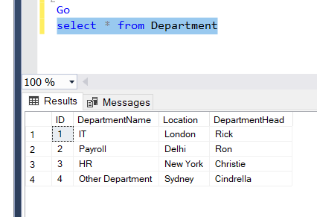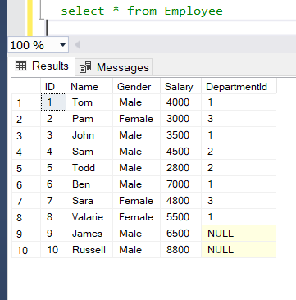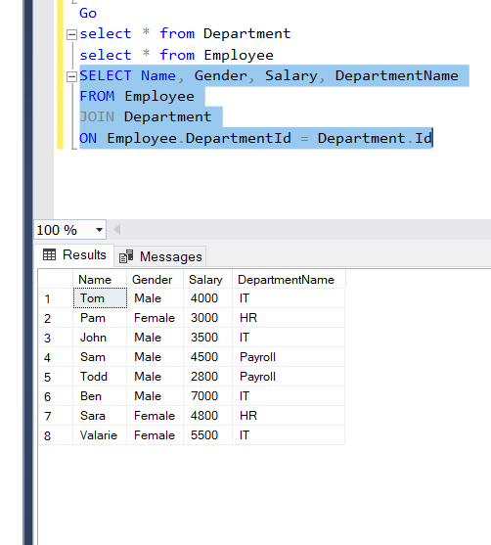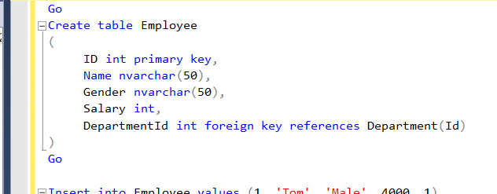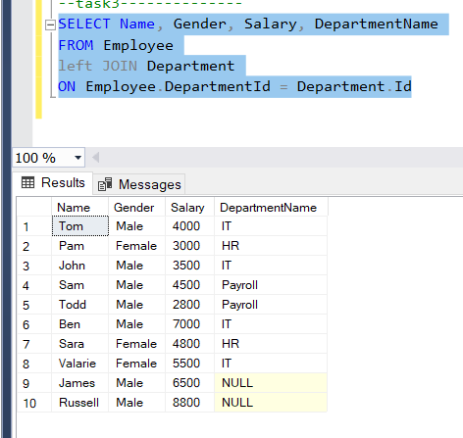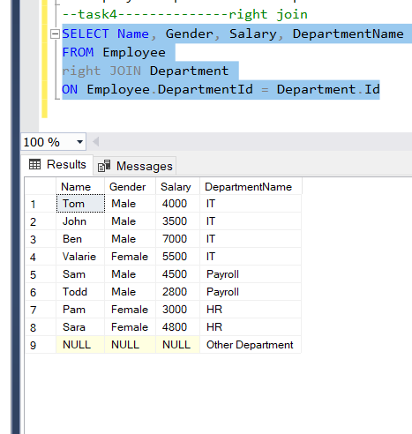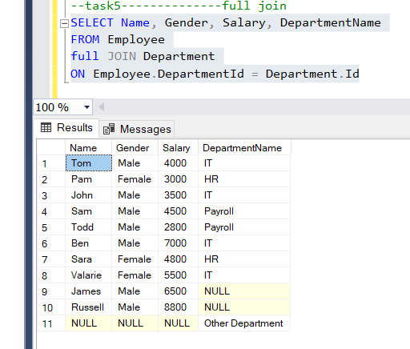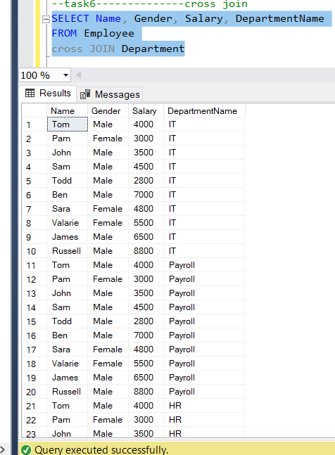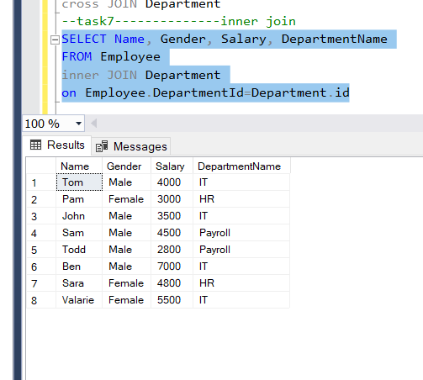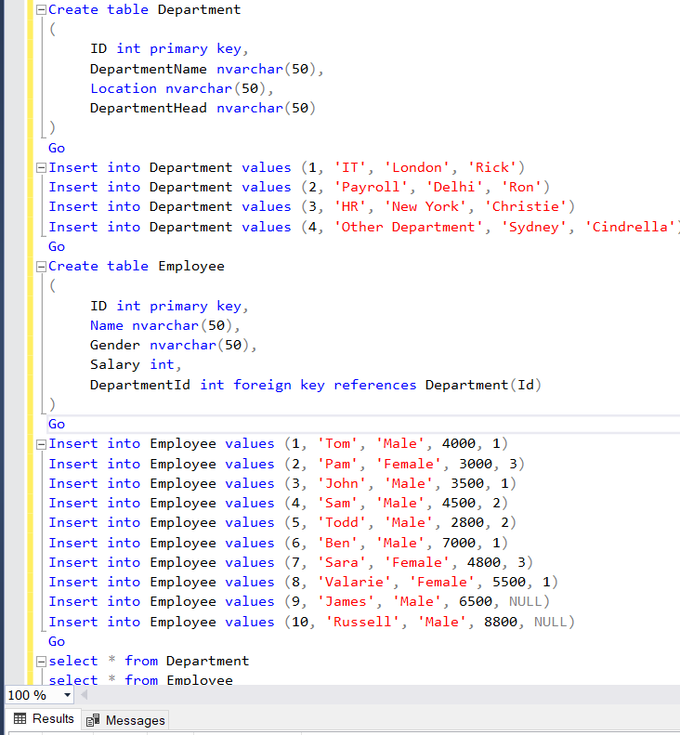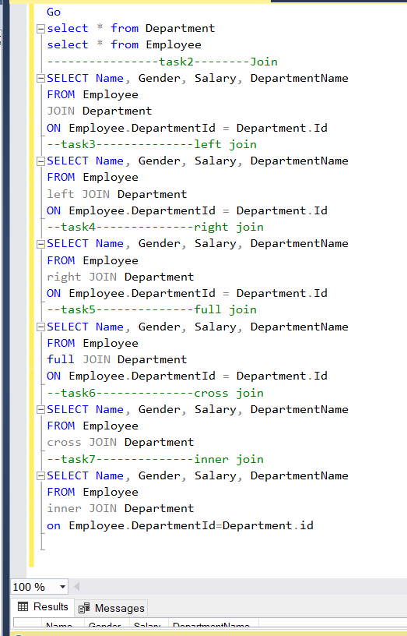

The aim of this article is to create tblPerson and tblGender tables and establish primary key and foreign key constraints. In SQL Server, tables can be created graphically using SQL Server Management Studio (SSMS) or using a query.

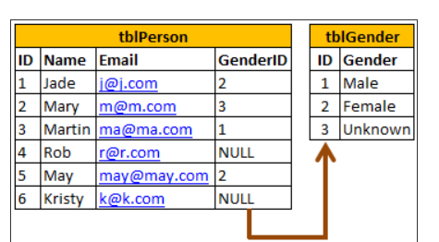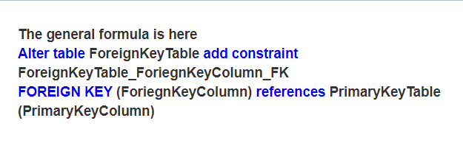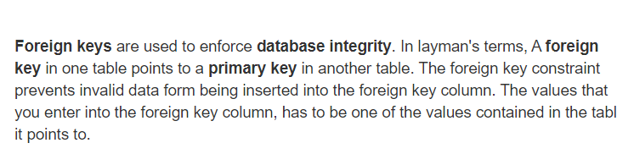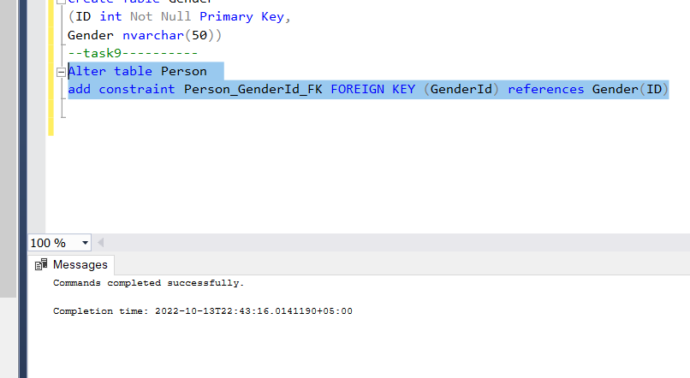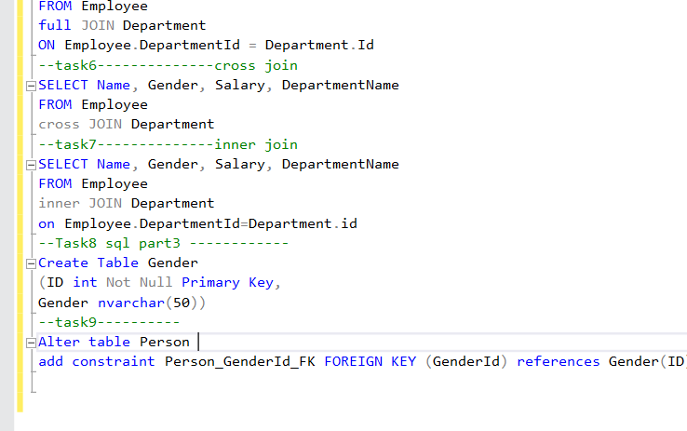

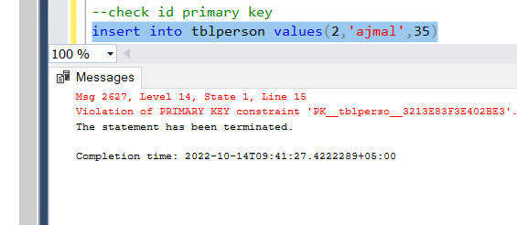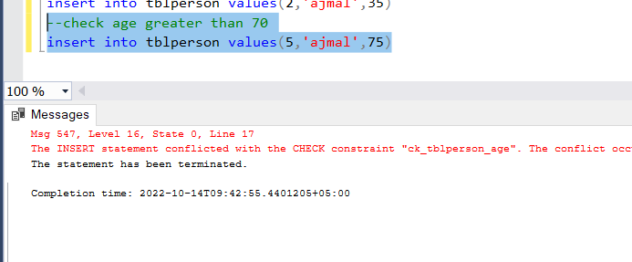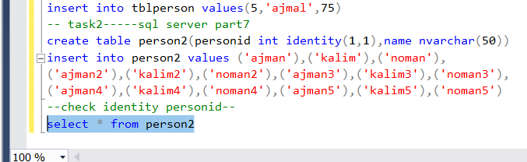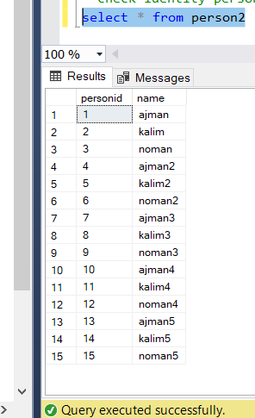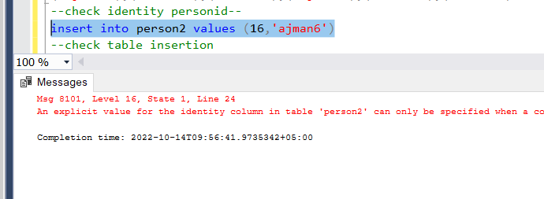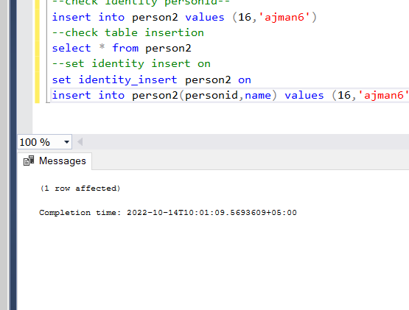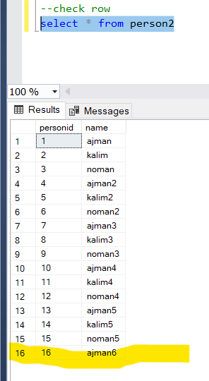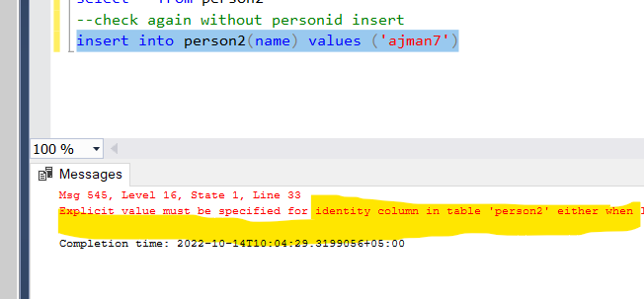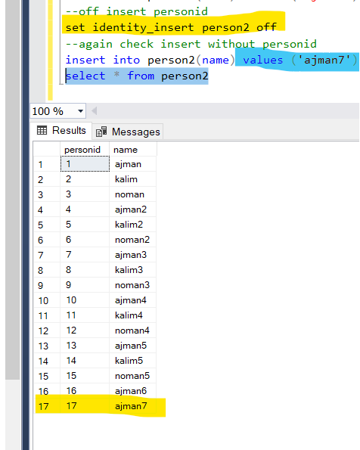

create the table..  
  
create table tblPers  
(  
Id int Identity(1,5),  
Name varchar(20)  
)  
  
  
Hi since Id here, is an identity column .. u cannot alter the Identity column directly,, so first u need to drop it and then add the Id column again as shown below...  
  
drop the column  
  
alter table tblPers  
drop column Id  
  
Add the column again  
  
alter table tblPers  
add Id int identity(5,1)

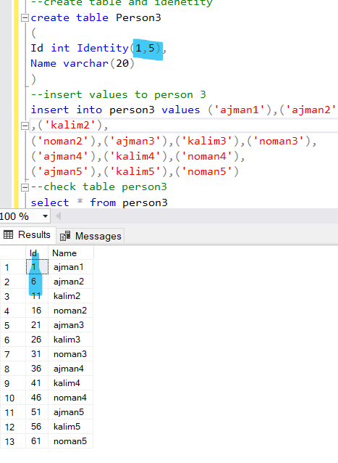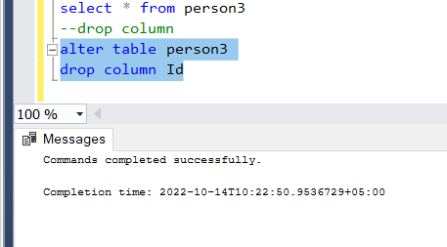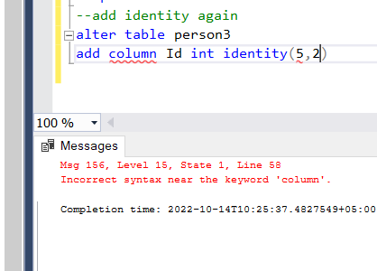

You can't alter the existing columns for identity.  
You have 2 options,  
Create a new table with identity & drop the existing table  
Create a new column with identity & drop the existing column  
  
Alter Table Names Drop Column ID  
Go

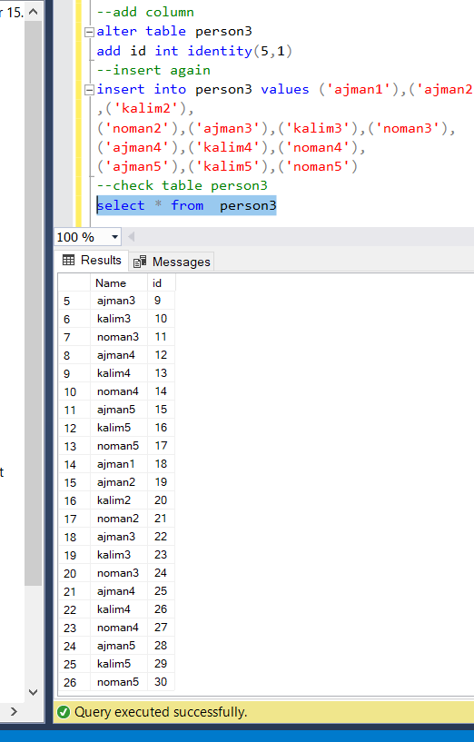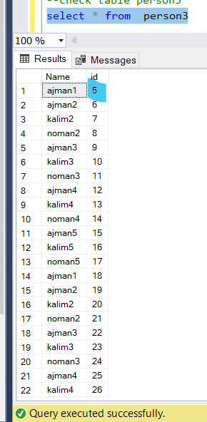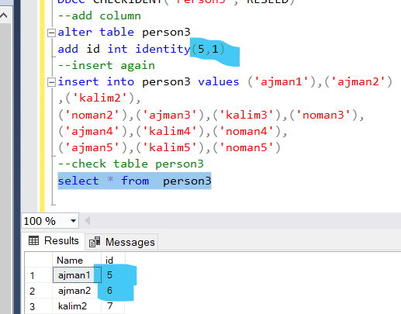

SCOPE_IDENTITY() - returns the last identity value that is created in the same session and in the same scope.  
@@IDENTITY - returns the last identity value that is created in the same session and across any scope.  
IDENT_CURRENT('TableName') - returns the last identity value that is created for a specific table across any session and any scope.

